**Exchange Server**

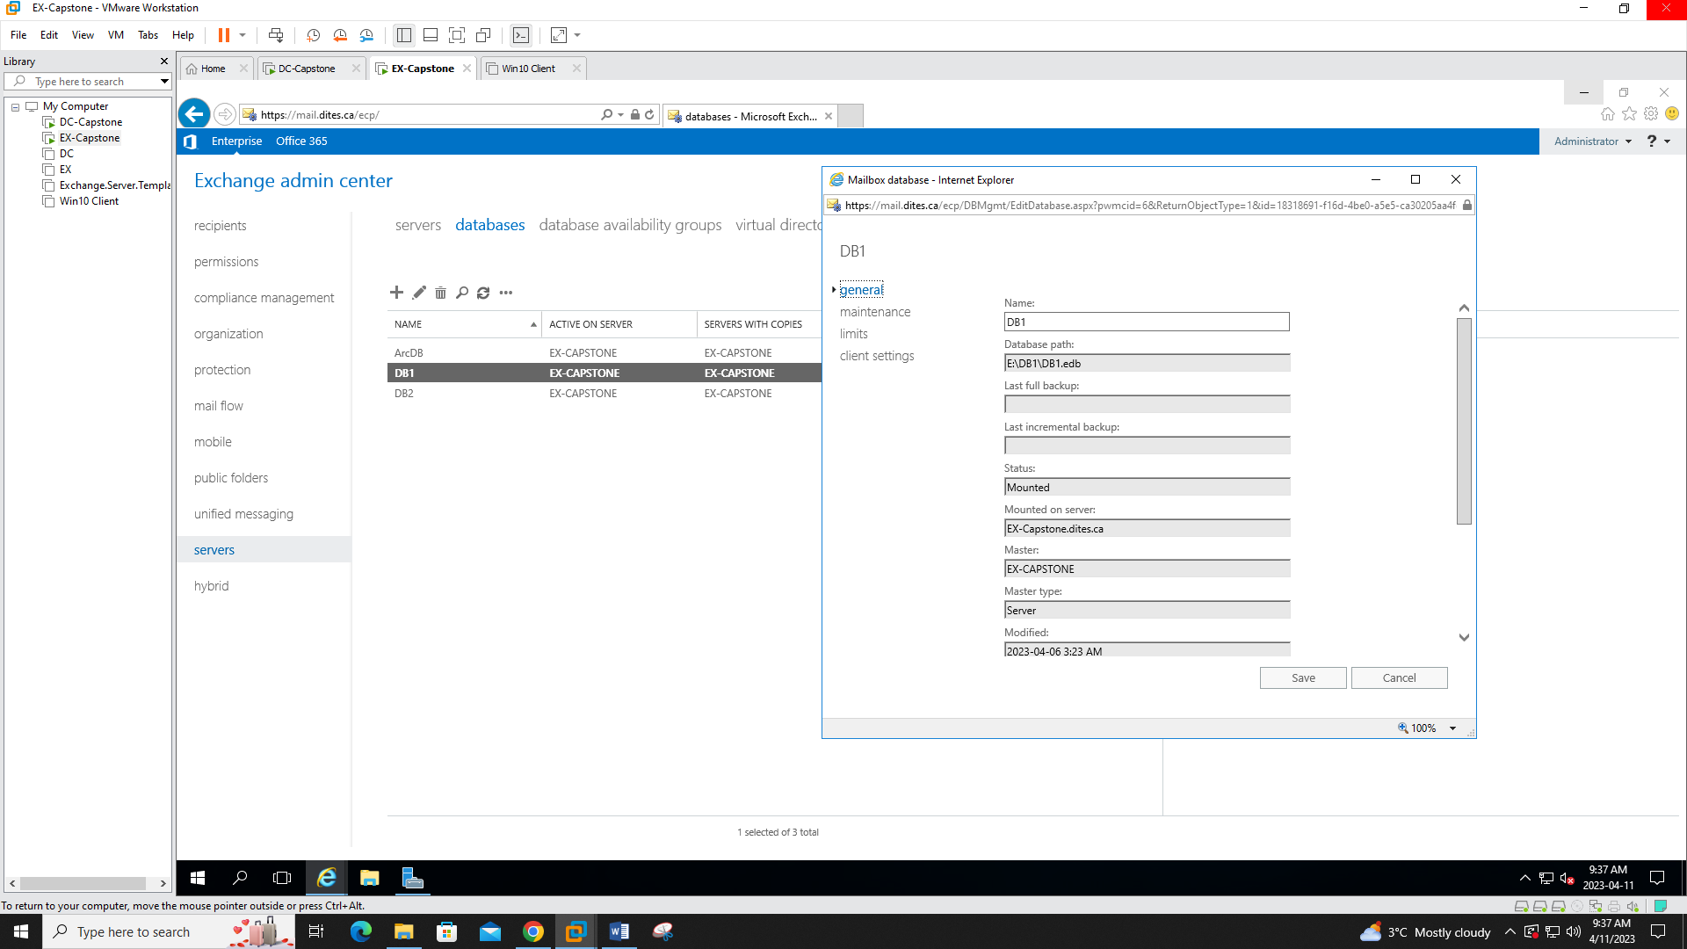

First we created extra databases DB1 and DB2 are on E drive and the ArchDB is on the F Drive

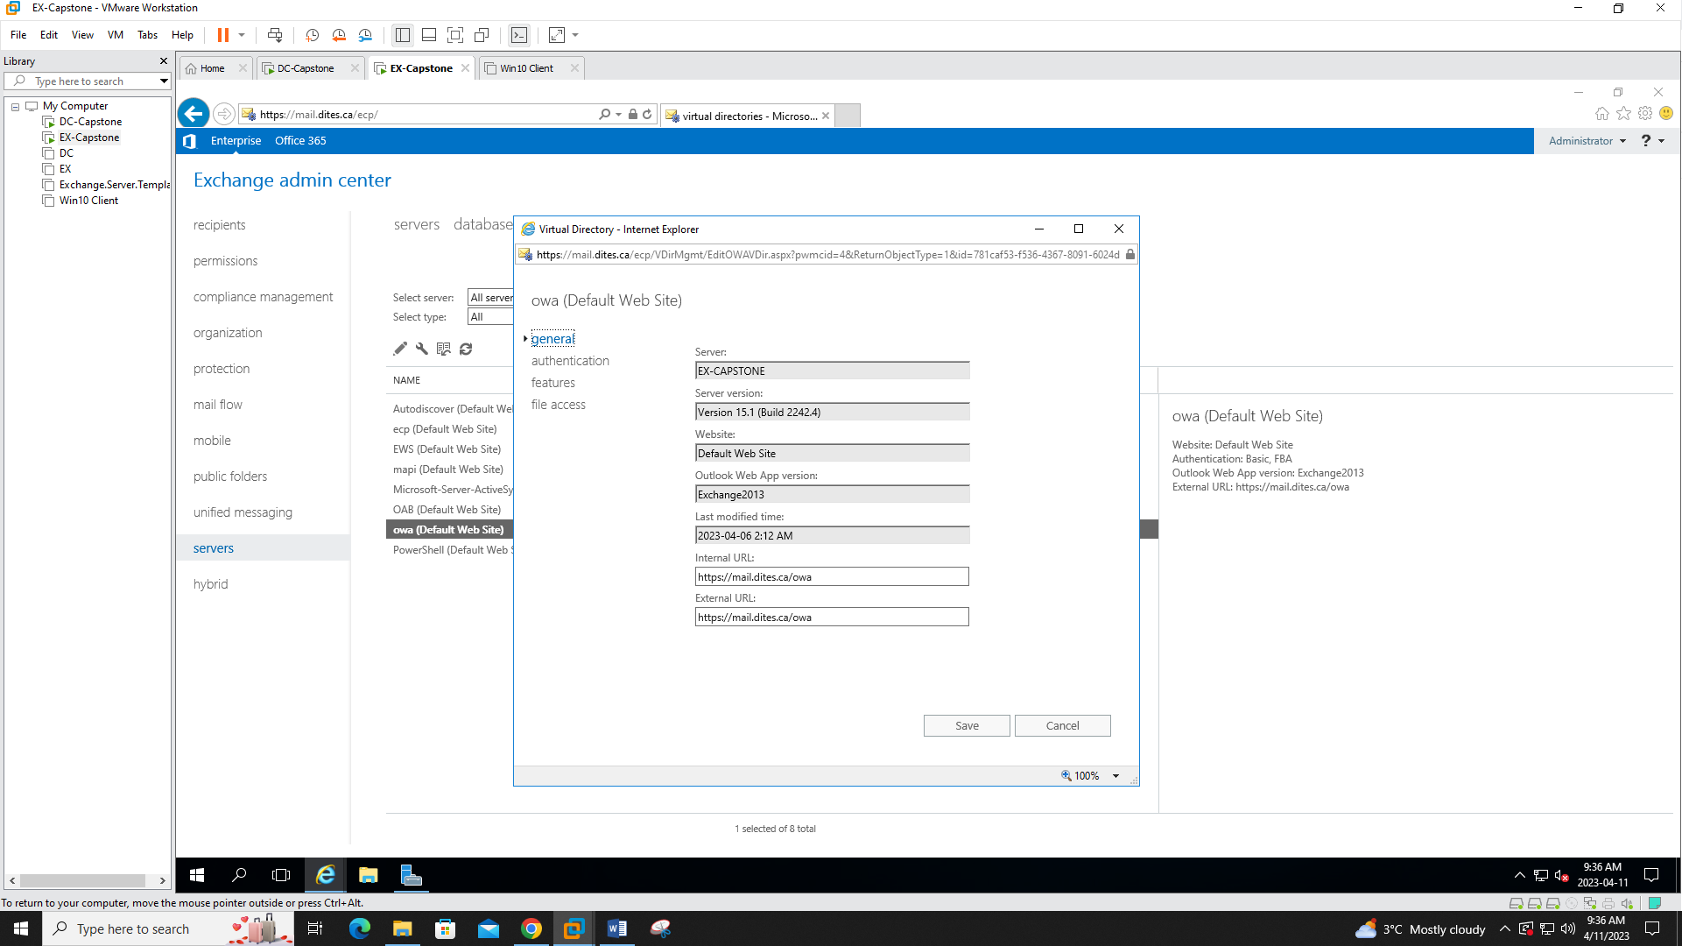

All of the directory links were changed to reflect our domain (I.e. mail.dites.ca)

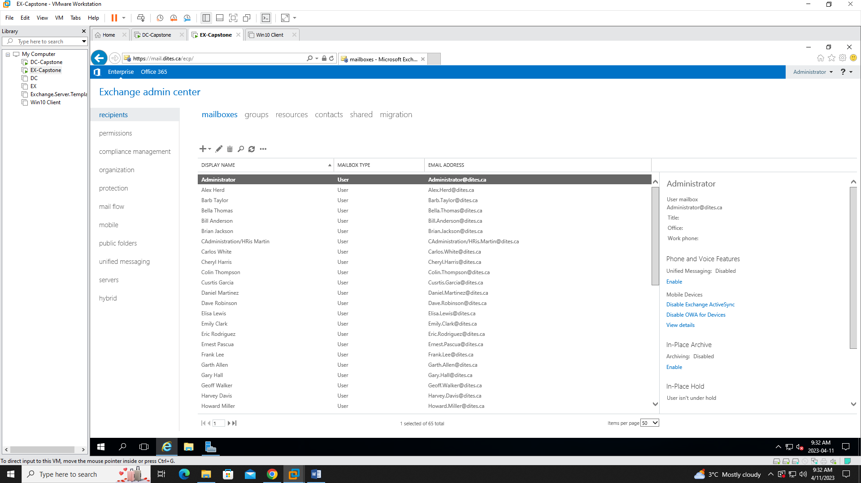

Users were imported through CSV file and sorted into proper OUs then the mailboxes were activated

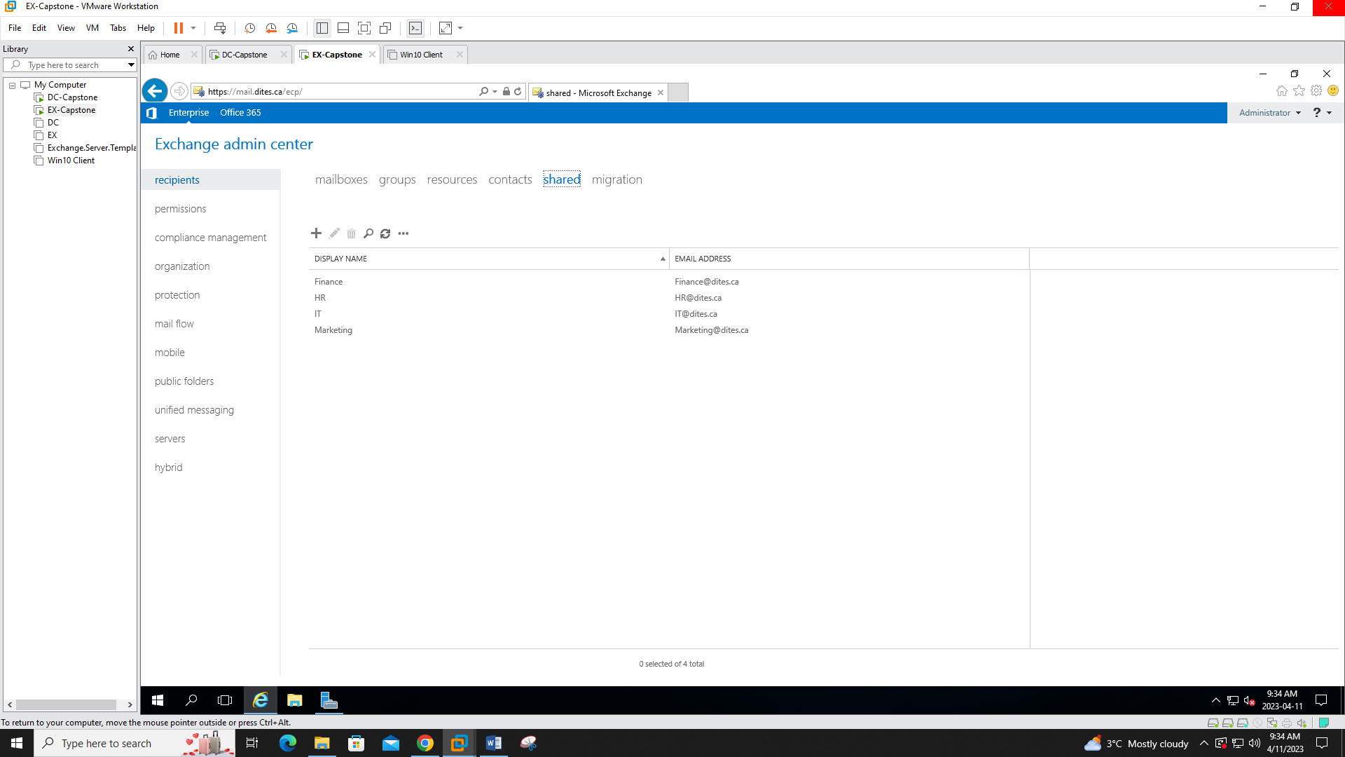

A shared mailbox was created for each department

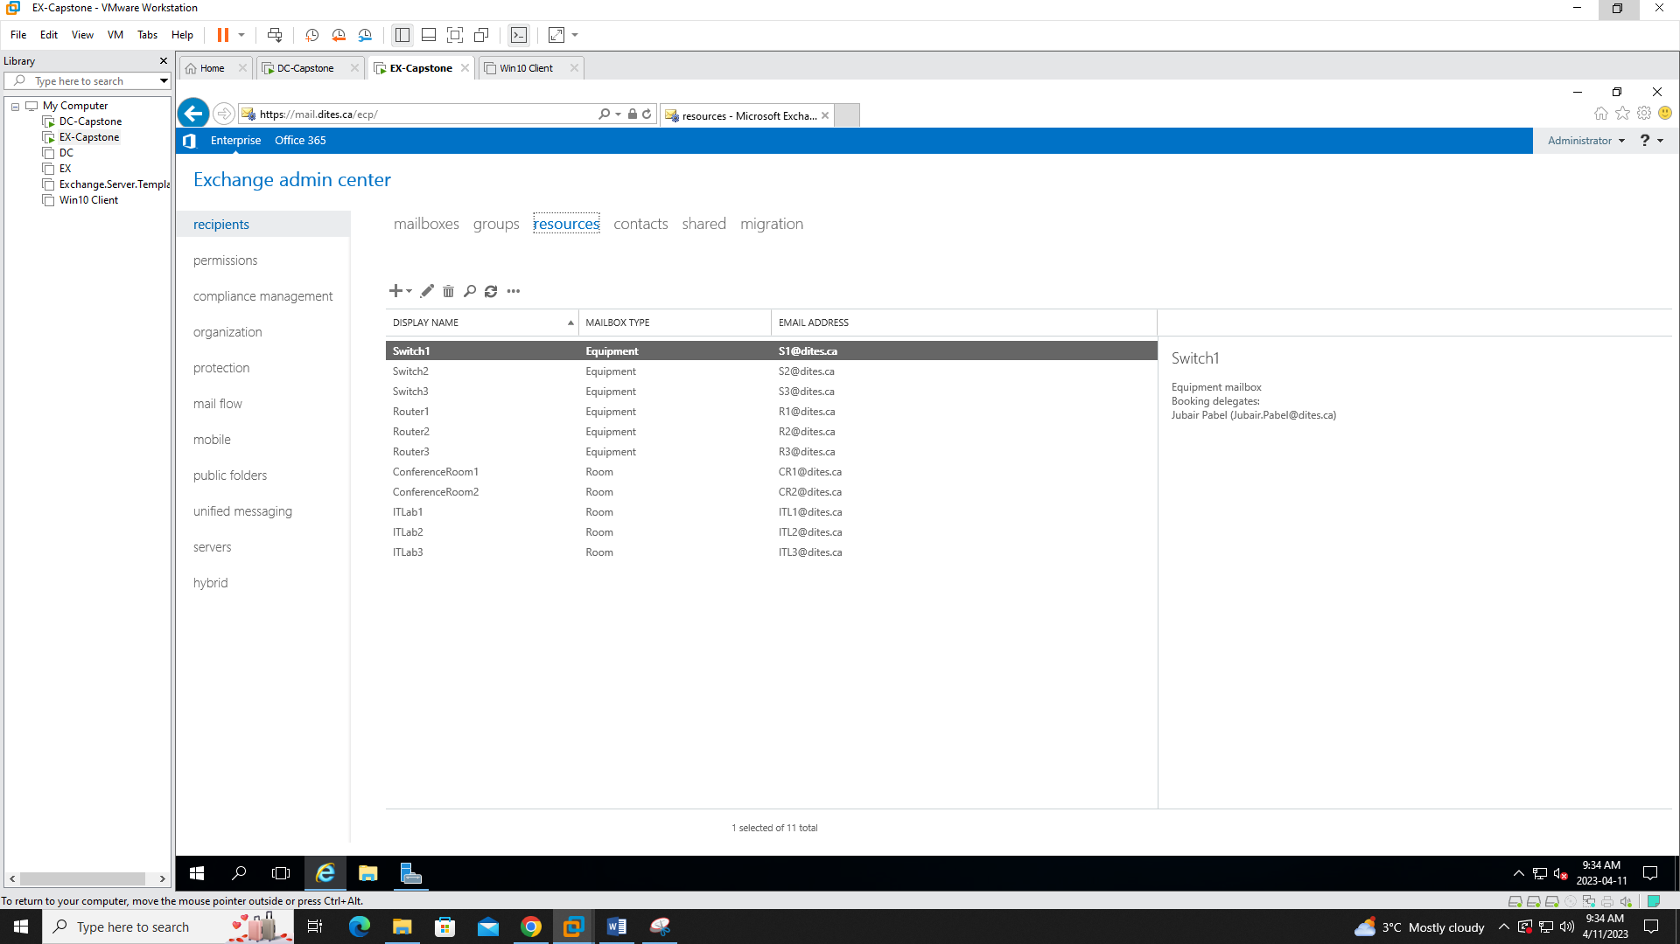

We also created resource mailboxes for the purpose of scheduling Conference rooms and IT labs as well as renting switches and routers for class purposes.

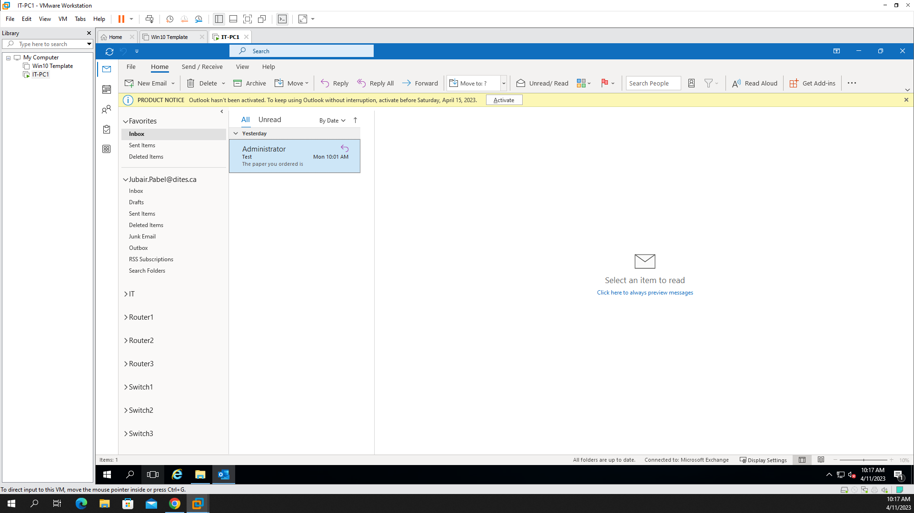

The above screenshot showcases the shared mailbox (IT) and resource mailboxes for equipment rentals in an outlook account for the IT head.

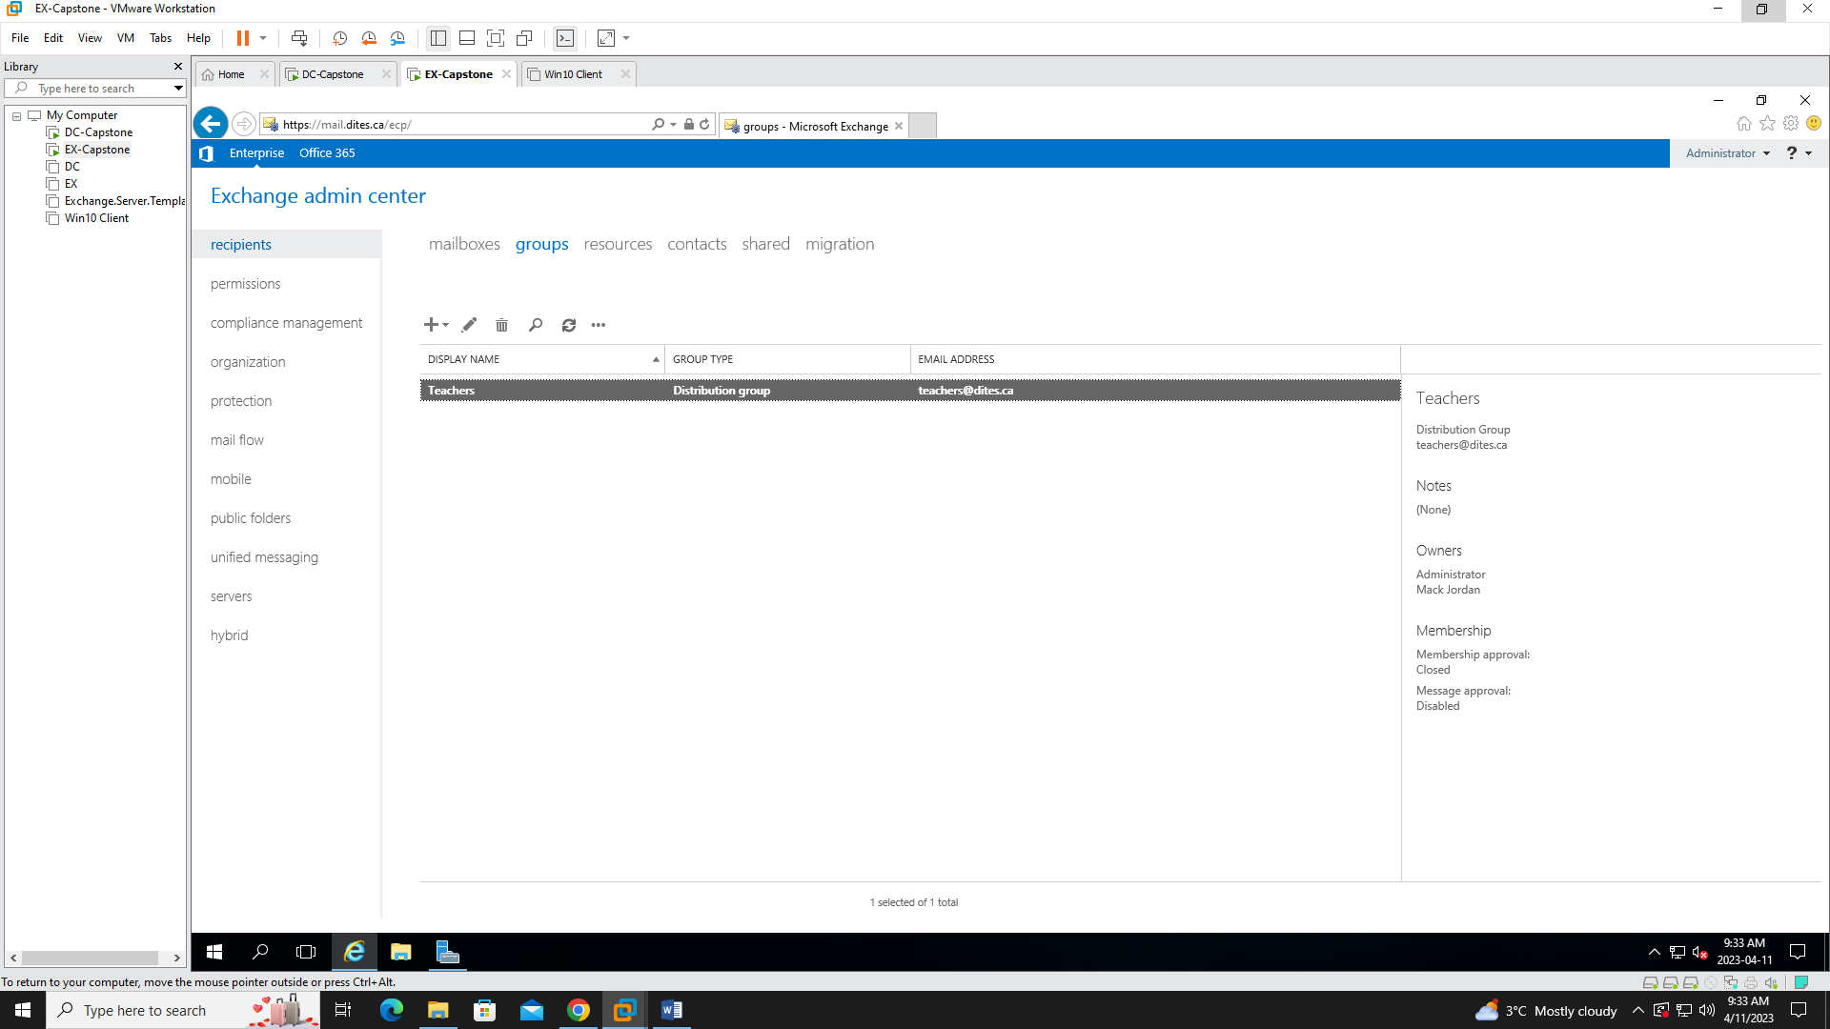A distribution group was created for the teachers.

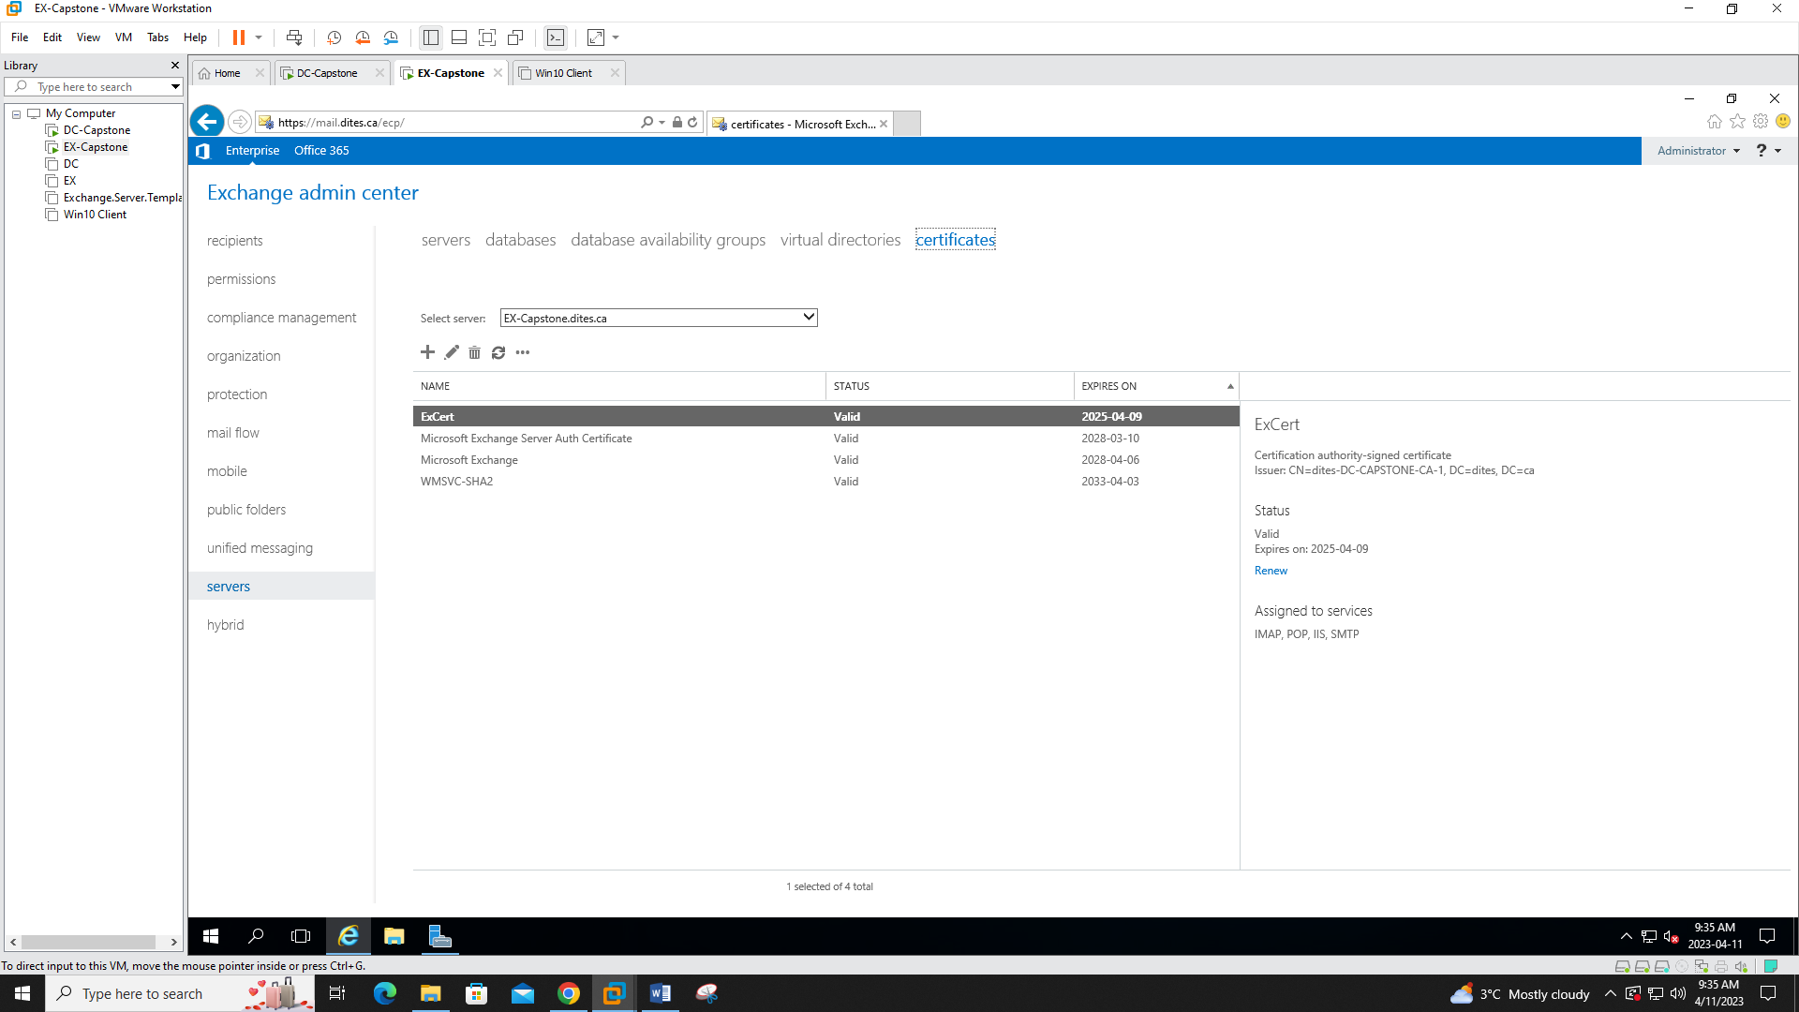Finally we used an internal SSL certificate to validate our Exchange Server.